**ASSIGNMENT:-06**

**EECE:-212**

**NAME: Shaharehar Rahaman Anik**

**Level: 2**

**ID No: 201916058**

**Here are some mathematical problem are solved by MATLAB 2020a.according to the questions. The answers are given bellow:**

**Numerically evaluate the following integrals with**

1. **Trapezoid Method**
2. **Simpson’s 1/3 Rule**
3. **Simpson’s 3/8 Rule**
$I= \int_{0}^{9}{\frac{xdx}{x^{2}+4}}$

4. $y=f\left(x\right)$**such that some coordinate pairs are given by-(x, y) = (1,-15.997) , (1.5, -17.966), (2,-19.808), (2.5, -21.267), (3, -21.813), (3.5, -20.458), (4,-15.712), (4.5, -5.089), (5,14.875), (5.5, 49.042), (6,103.968), (6.5,188.257), (7, 312.947)**

**Compare the results with analytical integrals. For the first integral, comment on the accuracy of the result with variation of h (distance between two x coordinates). For both integrals, compare the accuracy of the 3 methods you used.**

**Solution:**

Here have to find out the integrated value for 2 types of math by three methods, and also have to compare the accuracy of the three methods used. The program is given bellow.

$I= \int_{0}^{9}{\frac{xdx}{x^{2}+4}}$

Is solved in three methods,

**Trapezoid Method:**

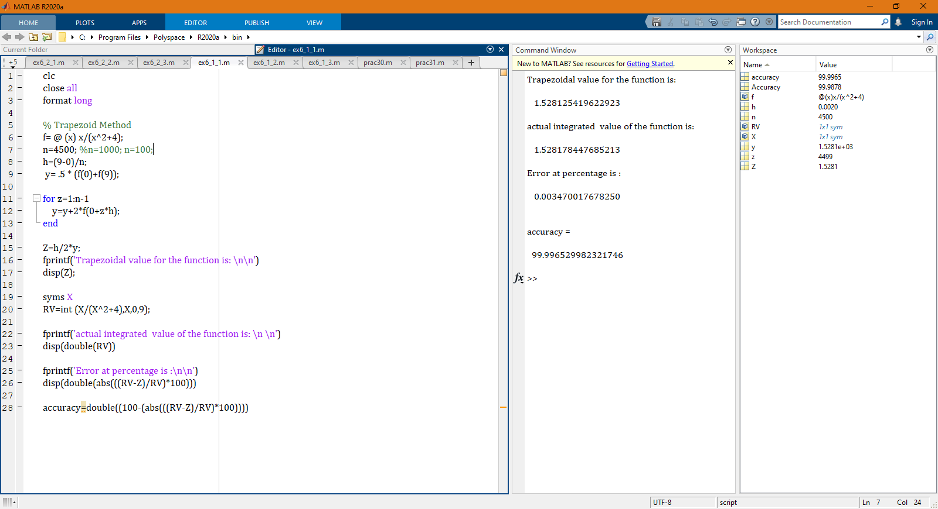

Here,

Trapezoidal value for the function is:

**1.528125419622923**

Actual integrated value of the function is:

**1.528178447685213**

Error at percentage is:

**0.003470017678250%**

Accuracy =

**99.996529982321746%**

**And** the more the value of **h** increase. The more the error is increase. So I put **n=4500**. Which make the value of h more **miniature**.

**Simpson’s 1/3 Rule:**

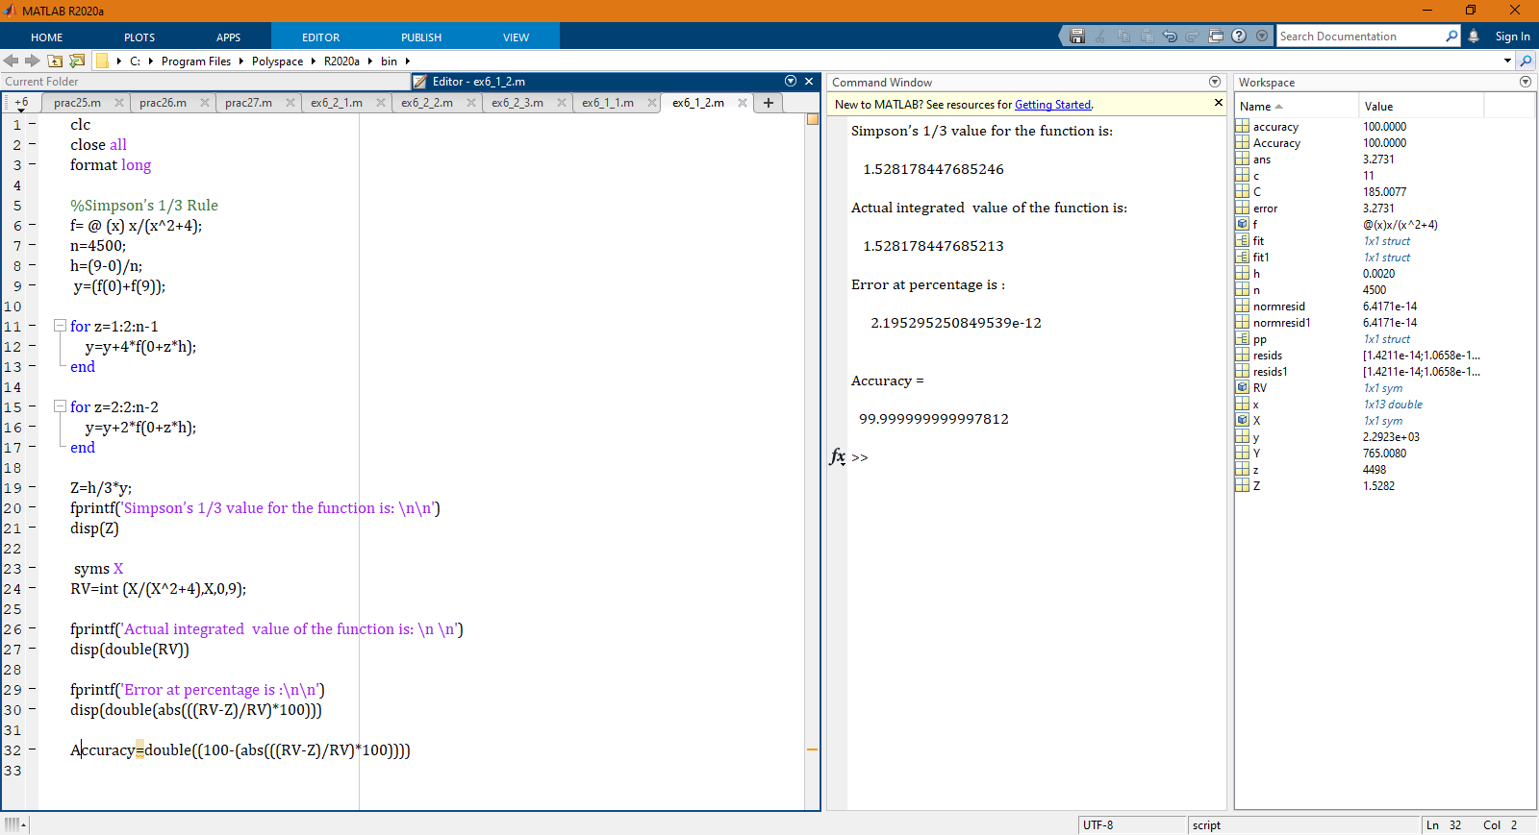

**Here,**

Simpson’s 1/3 value for the function is:

**1.528178447685246**

Actual integrated value of the function is:

**1.528178447685213**

Error at percentage is:

**2.195295250849539e-12%**

Accuracy =

**99.999999999997812%**

**And** the more the value of **h** increase. The more the error is increase. So I put **n=4500**. Which make the value of h more **miniature**.

**Simpson’s 3/8 Rule:**

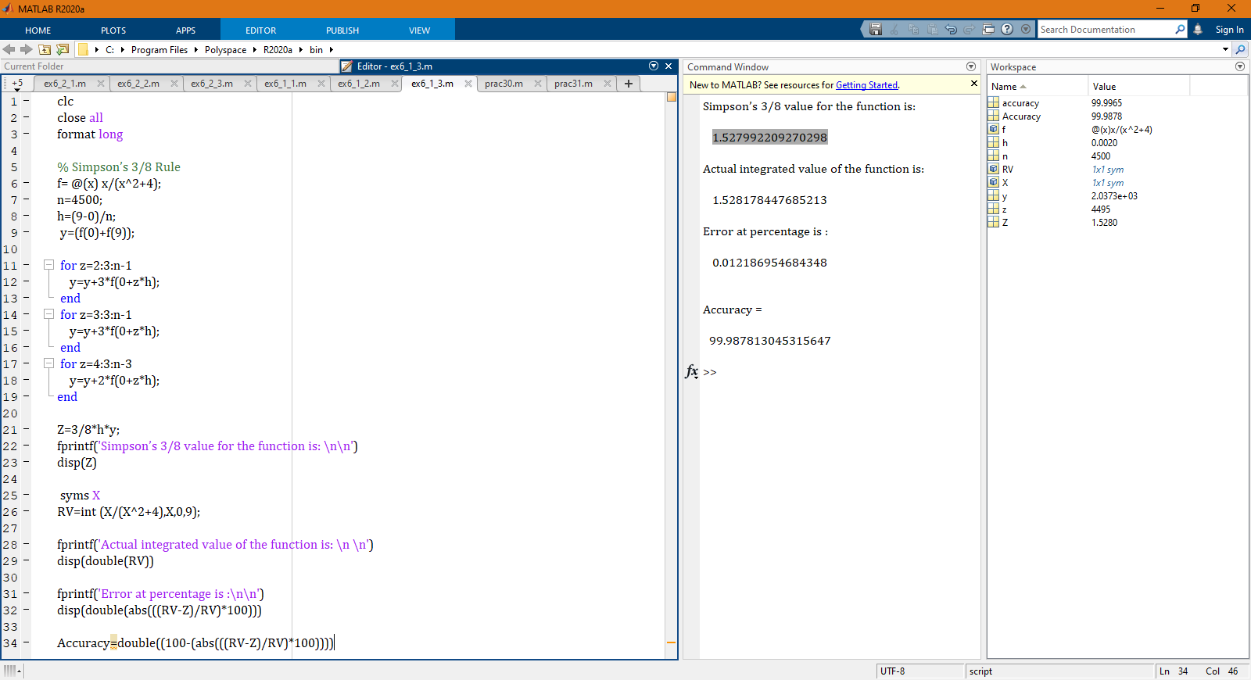**Here,**

Simpson’s 3/8 value for the function is:

**1.527992209270298**

Actual integrated value of the function is:

**1.528178447685213**

Error at percentage is:

**0.012186954684348%**

Accuracy:

**99.987813045315647%**

**And** the more the value of **h** increase. The more the error is increase. So I put **n=4500**. Which make the value of h more **miniature**.

**Comment:**

**All are much accurate. Because the value of h is too small. If I increase the value of h its accuracy will decrease. To compare these method I can say that “**Simpson’s 1/3 Rule**” has most accuracy among them**.

**(b) $y=f\left(x\right)$ Such that some coordinate pairs are given by-(x, y) = (1,-15.997), (1.5, -17.966), (2,-19.808), (2.5, -21.267), (3, -21.813), (3.5, -20.458), (4,-15.712), (4.5, -5.089), (5, 14.875), (5.5, 49.042), (6,103.968), (6.5, 188.257), (7, 312.947)**

Here to calculate the accuracy, **we need an equation**. So **I plot the values** and **will get an equation** from the basic fitting of the graph.

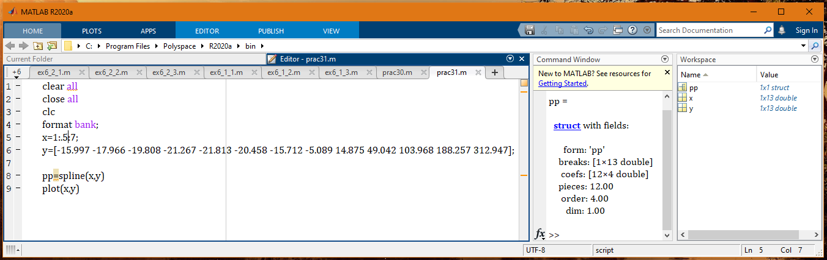

**The graph according the value is:**

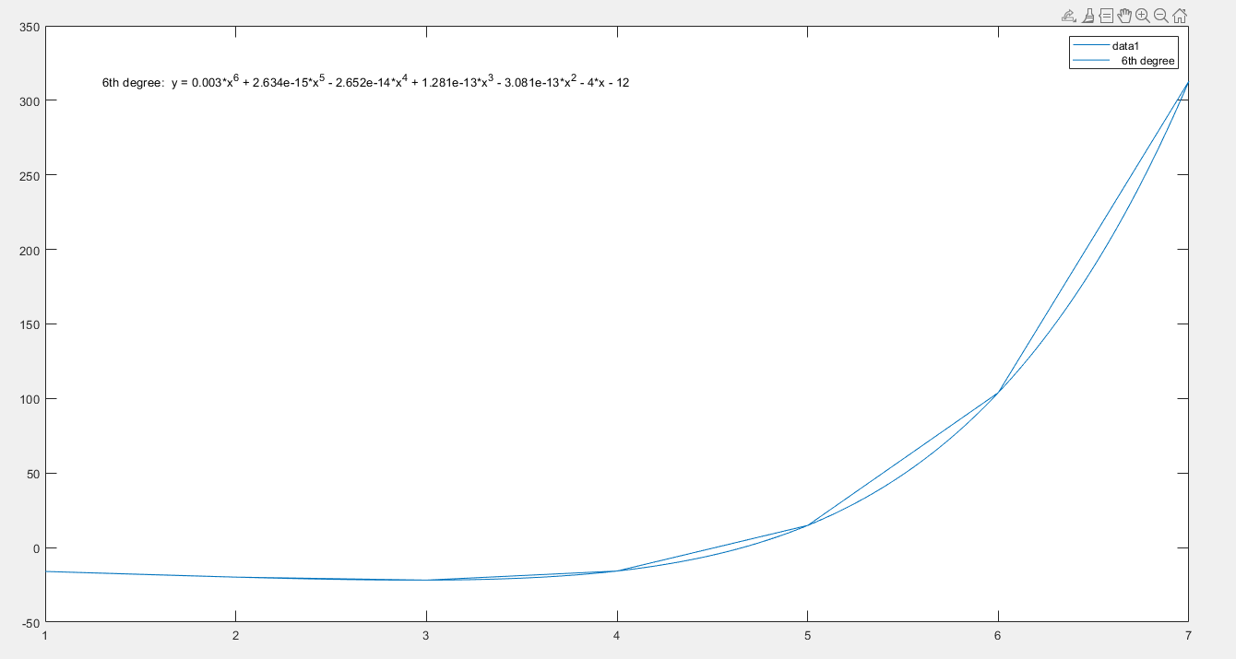**The equation is**:

**y = 0.003*x^6 + 2.6338e-15*x^5 -2.6521e-14*x^4 + 1.2812e-13*x^3 -3.0805e-13*x^2 -4*x -12**

Now again the equation is solves by three methods. These are:

1. Trapezoid Method
2. Simpson’s 1/3 Rule
3. Simpson’s 3/8 Rule

**The programs are given bellow:**

**Trapezoid Method:** 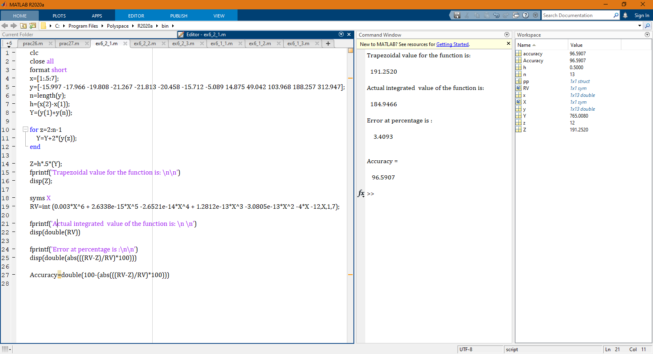

Here,

Trapezoidal value for the function is:

**191.2520**

Actual integrated value of the function is:

**184.9466**

Error at percentage is:

**3.4093%**

Accuracy =

**96.5907%**

**Simpson’s 1/3 Rule:**

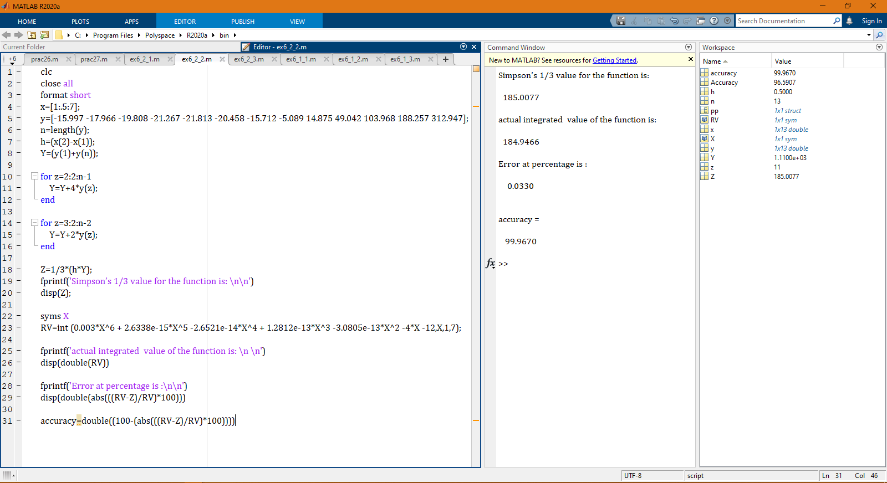

**Here,**

Function Simpson’s 1/3 value for the is:

**185.0077**

Actual integrated value of the function is:

**184.9466**

Error at percentage is:

**0.0330%**

Accuracy:

**99.9670%**

**Simpson’s 3/8 Rule:**

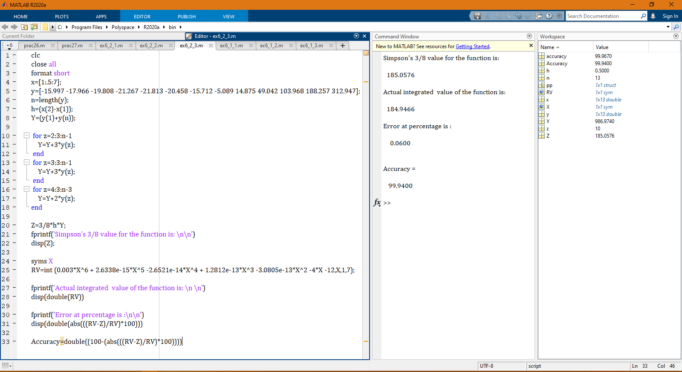

**Here,**

Simpson’s 3/8 value for the function is**:**

**185.0576**

Actual integrated value of the function is:

**184.9466**

Error at percentage is:

**0.0600%**

Accuracy:

**99.9400%**

**Comment:**

**\*\* To compare these method I can say that again “Simpson’s 1/3 Rule” has most accuracy among them. \*\***